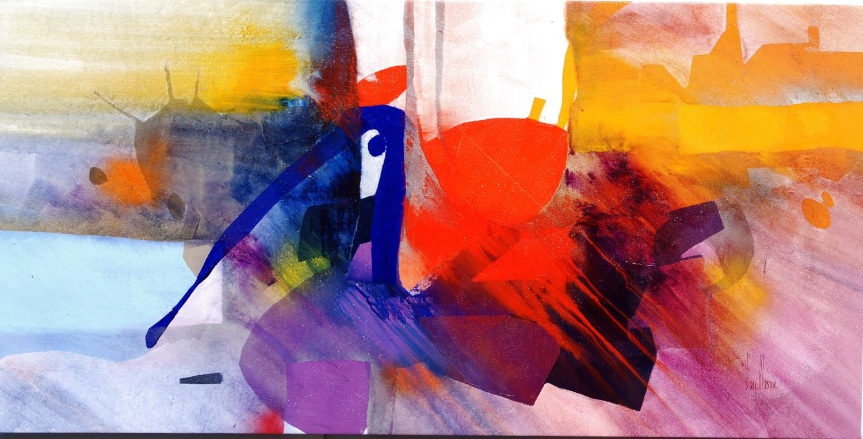
Artist and entrepreneur, Gregory Hawthorne founded the Hawthorne Gallery in Big Sur in 1995. Gregory, his wife Susan and friends spent an afternoon at Nepenthe restaurant 26 years ago. To the amusement of his family and friends, Gregory announced that he would build his studio, and create a dynamic art gallery, “across the street.”
Perhaps those who knew Gregory as an art student at Wayne State University, and before, as a gifted parochial student in a suburb of Detroit, would not be surprised to learn that, several years and much hard work later, his dream came true.
His varied creations offer a kaleidoscope of moving, changing sensations that will flex your imagination. His work encompasses a remarkable variety of mediums from paintings and full color human figures to outdoor acid-etched sculptures and furniture that is truly functional art.
Gregory’s work is the expression of his observations of people, current events and personal interests.
He believes art to be “a continuous process, influenced by all aspects of a changing society.” His artwork is displayed in hundreds of private and corporate collections worldwide.
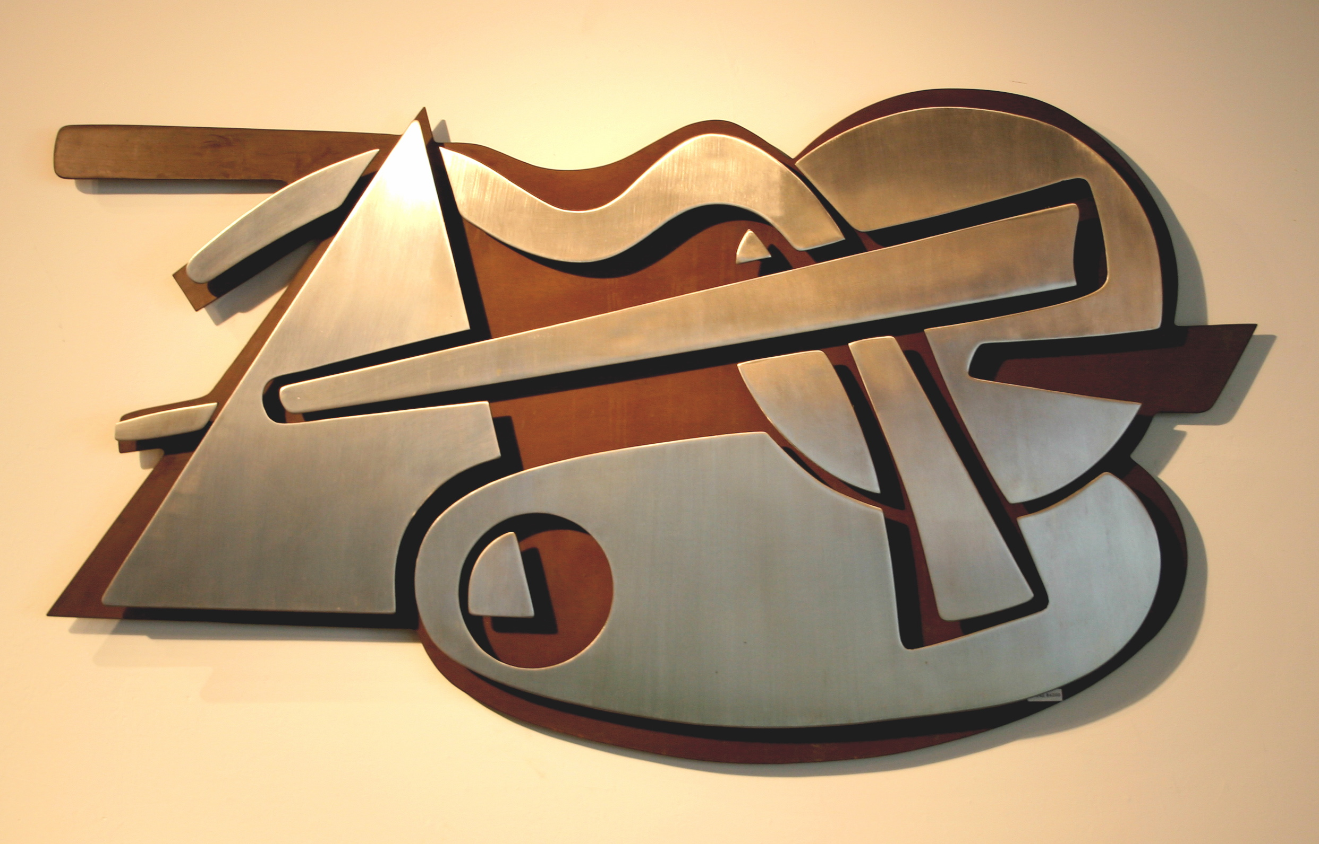
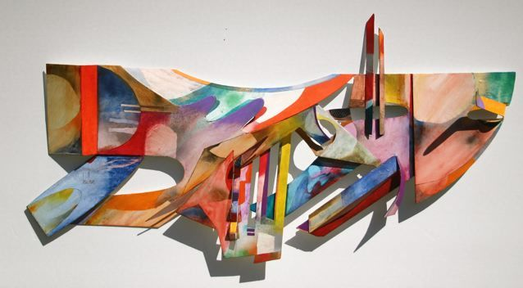
Gregory’s provocative imagery incorporates his three loves, painting, sculpting and design. His large figurative sculptures express his ebullient nature. You’ll find examples of all of Gregory’s work at the gallery.
A long cherished dream to sculpt large granite water features in now coming true as Gregory collaborates with local sculptor Frederick Gregory to create unique water features.
“My hope is to raise awareness of the arts through the gallery, as well as to provide lovers of the arts with beautiful, superior works to enjoy in their homes, “ explains Gregory. “I consider the Gallery a kind of “Hall of Fame” of accomplished artists. Our goal is to professionally represent all of our artists with loving care and knowledge.

